**HIGH LEVEL DIAGRAM**

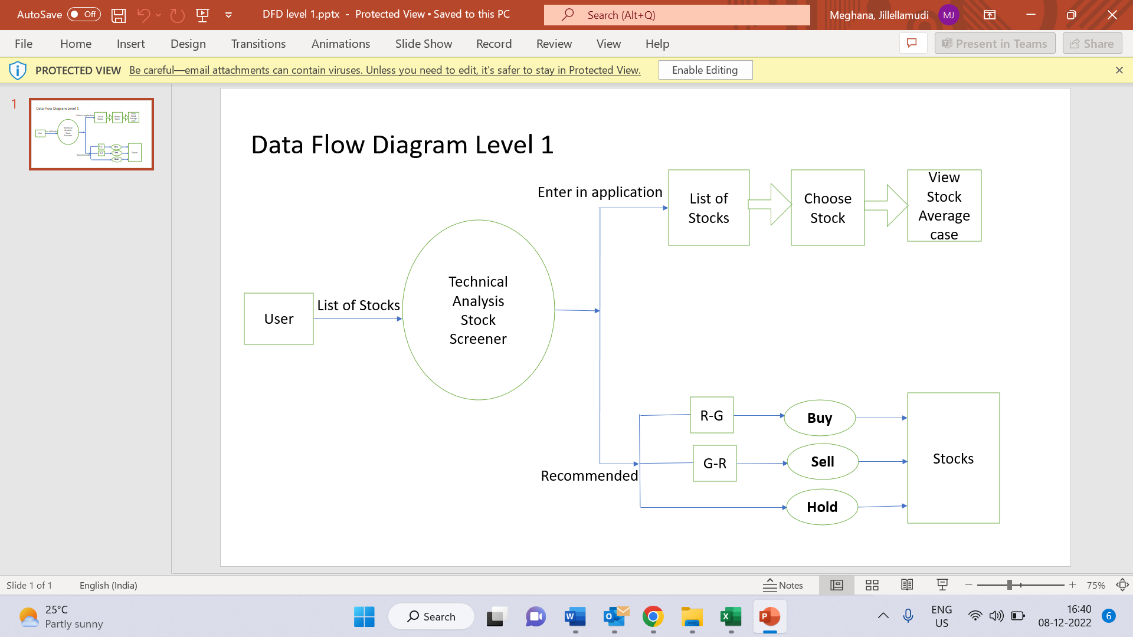

**LOW LEVEL DIAGRAM**

